**UML for LL Bean**

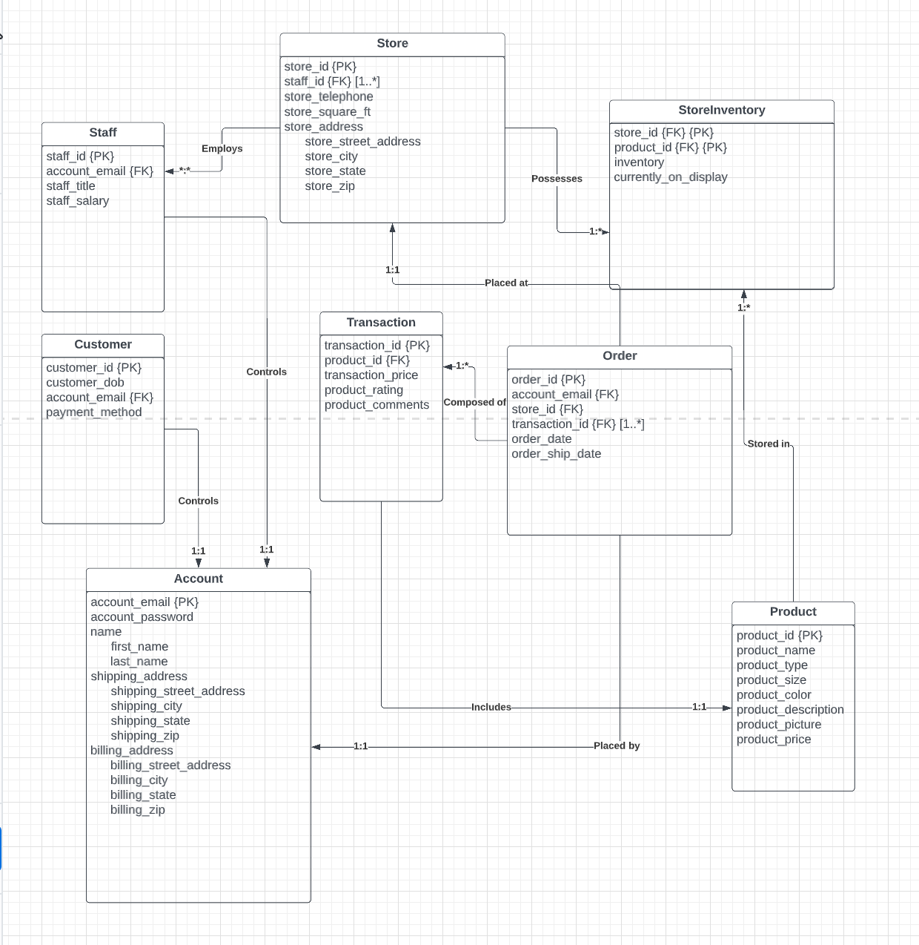

**Convert UML to Relations**

Key

* Primary Key is underlined
* Foreign Key is *italic*

Relations

**Customer**(customer_id, customer_dob, *account_email*, payment_method)

* This relation identifies attributes for the customer.
* There is 1 tuple for every account that has placed an order (in other words, every customer).
* The attribute *account_email* is a foreign key to the Account relation, which stores more information about each customer.
* degree: 4

**Staff**(staff_id, *account_email*, *staff_title*, staff_salary)

* This relation identifies attributes for the staff members.
* There is 1 tuple for each LL Bean staff member.
* The attribute *account_email* is a foreign key to the Account relation, which stores more information about each staff member.
* staff_title is a foreign key to the Staff_Title relation, which restricts the domain.
* degree: 4

**Staff_Title**(staff_title)

* This relation identifies all possible titles for staff
* This relation serves to restrict the domain of staff_title to allowable values (manager, sales associate, etc)
* degree: 1

**Store**(store_id, store_telephone, store_square_ft, store_street_address, store_city, store_state, store_zip)

* This relation identifies attributes for both physical stores and the online store.
* This relation does not include the multi-value attribute staff_id.
* To keep track of online availability, there will be a store named “online,” and attributes such as store_telephone, store_square_ft, and store_state will be null.
* degree: 7

**StoreInventory**(*store_id, product_id*, inventory, currently_on_display)

* This relation associates products with stores.
* There is 1 tuple for every instance of a product occurring at an individual store.
* The inventory attribute indicates how much of that particular product is currently available at that particular store. A product sold at a store brings the inventory down by one, while a shipment of a product to a store increases the inventory.
* The currently_on_display attribute indicates whether or not the store is currently showcasing the product.
* store_id and product_id are composite primary keys.
* degree: 4

**Product**(product_id, product_name, *product_type*, *product_size*, product_color, product_description, product_picture, product_price)

* This relation identifies attributes for the products.
* There is 1 tuple for each unique product sold by LL Bean.
* product_size is a foreign key to the Product_Size relation, which restricts the domain.
* product_type is a foreign key to the Product_Type relation, which restricts the domain.
* degree: 8

**Product_Size**(product_size)

* This relation identifies all possible sizes for products
* This relation serves to restrict the domain of product_size to allowable values (such as S, M, L, and XL)
* degree: 1

**Product_Type**(product_type)

* This relation identifies all possible types for products
* This relation serves to restrict the domain of product_type to allowable values
* degree: 1

**Account**(account_email, account_password, first_name, last_name, shipping_street_address, shipping_city, shipping_state, shipping_zip, billing_street_address, billing_city, billing_state, billing_zip)

* This relation identifies attributes for an account holder, which includes both customers and staff members.
* An account holder can also include people who created an account but never made a purchase or worked at a store, and therefore are neither a customer nor a staff member.
* The primary key is the account_email, which means that each email can only correspond to one account.
* For customers, the account stores their shipping address and billing address. For employees, a shipping address is required as well (to send holiday gifts) and a billing address is needed for paychecks.
* One central account simplifies tasks for employees, as they only need one login (even when ordering products for themselves).
* One central account also makes it easier to identify possible employee fraud, since all purchases will be made using their company account
* degree: 12

**Order**(order_id, order_date, order_ship_date, *account_email*, *store_id*)

* This relation identifies attributes for orders.
* An order is a collection of individual product purchases which share an order_date, order_ship_date, and are placed by the same account_email
* An order is composed of at least one transaction. This relation does not include the multi-value attribute transaction_id.
* degree: 5

**Transaction**(transaction_id, *product_id*, transaction_price, product_rating, product_comments)

* This relation identifies attributes for transactions.
* There is 1 tuple for each product sold, since transactions correspond to the purchase of an individual product.
* A customer can assign a product_rating and provide a product description using product_comments.
* degree: 5

**StoreStaff**(*staff_id*, *store_id*)

* This relation associates staff and stores.
* staff_id and store_id are composite primary keys.
* A store employs at least one staff member. There is no restriction against staff working at multiple stores.
* There is 1 tuple for every instance of a staff member working at a store.
* degree: 2

**OrderTransaction**(*order_id*, *transaction_id*)

* This relation associates orders and transactions.
* order_id and transaction_id are composite primary keys.
* A transaction can only be a part of a single order. An order must have at least one transaction.
* degree: 2

**Domain**

* customer_dob, order_date, order_ship_date: Datetime value
* store_telephone: 10 digit number
* store_state: 50 state codes plus can be NULL for online
* store_zip, shipping_zip, billing_zip: valid zip codes
* currently_on_display: true/false
* account_email: email value
* shipping_state, billing_state: 50 state codes
* product_rating: integer between 1 and 5

1. Identify the 12 month purchase history for Jesper Bratt. Display the customer name, product, size, price, date of purchase.

last12 <- 𝛿order_date > “2021-10-16 00:00:00” (Order)

bratt <- 𝛿first_name = “Jesper” ⋀ last_name = “Bratt” (Account)

brattlast12 <- 𝛿bratt.account_email = last12.account_email (bratt x last12)

bratt12ot <- 𝛿brattlast12.order_id = OrderTransaction.order_id (brattlast12 x OrderTransaction)

bratt12t <- 𝛿bratt12ot.transaction_id = Transaction.transaction_id (bratt12ot x Transaction)

bratt12p <- 𝛿bratt12t.product_id = Product.product_id (bratt12t x Product)

Answer <- Πfirst_name,last_name,product_name,product_size,transaction_price,order_date(bratt12p)

1. Identify polo shirts, size medium available now at the Jeffersonville, Ohio location. Display the product name, product code, available colors and price.

jo <- 𝛿store_city = “Jeffersonville” ⋀ store_state = “OH” (Store)

joinven <- 𝛿jo.store_id = StoreInventory.store_id (jo x StoreInventory)

joavail <- 𝛿inventory > 0 ⋀ currently_on_display = TRUE (joinven)

joprod <- 𝛿joavail.product_id = Product.product_id (joavail x Product)

jomedpolo <- 𝛿product_type = “Polo Shirt” ⋀ product_size = “M” (joprod)

Answer <- Πproduct_name,product_id,product_color,product_price (jomedpolo)

1. Identify when the recent order for Jesper Bratt will be shipped. Display the products ordered, price and ship date.

bratt <- 𝛿first_name = “Jesper” ⋀ last_name = “Bratt” (Account)

brattorders <- 𝛿bratt.account_email = Order.account_email(bratt x Order)

brattordersclone <- 𝛿bratt.account_email = Order.account_email(bratt x Order)

brattoldorders <- 𝛿brattorders.order_date < brattordersclone.order_date(brattorders x brattordersclone)

brattrecentorder <- Πorder_date(brattorders) - Πbrattorders.order_date(brattoldorders)

a <- 𝛿brattrecentorder.order_id = OrderTransaction.order_id(brattrecentorder x OrderTransaction)

brattrecenttrans <- 𝛿a.transaction_id = Transaction.transaction_id(a x Transaction)

brattrecentprods <- 𝛿brattrecenttrans.product_id = Product.product_id(brattrecenttrans x Product)

Answer <- Πproduct_name,transaction_price,order_ship_date(brattrecentprods)

1. Identify products with no inventory offered at the web store. Display the product name, product code, size and color.

online <- 𝛿store_state = NULL(Store)

onlineinven <- 𝛿online.store_id = StoreInventory.store_id(online x StoreInventory)

onlineavail <- 𝛿inventory > 0 ⋀ currently_on_display = TRUE (onlineinven)

onlinenotavail <- Πproduct_id(Product) - Πproduct_id(onlineavail)

onlinenotavailp <- 𝛿onlinenotavail.product_id =Product.product_id(onlinenotavail x Product)

Answer <- Πproduct_name,product_id,product_size,product_color(onlinenotavailp)

1. Identify button-down shirts not sold in the last month at the web store. Display the product name, product code, size, color and price.

online <- 𝛿store_state = NULL(Store)

onlineorders <- 𝛿online.store_id = Order.store_id(online x Order)

monthorders <- 𝛿order_date>”2022-09-16 00:00:00” (onlineorders)

monthordertrans <- 𝛿monthorders.order_id = OrderTransaction.order_id(monthorders x OrderTransaction)

monthtrans <- 𝛿monthordertrans.transaction_id = Transaction.transaction_id(monthordertrans x Transaction)

monthprods <- 𝛿monthtrans.product_id = Product.product_id(monthtrans x Product)

monthbdshirts <- 𝛿product_type = “Button-down Shirt”(monthprods)

allbdshirts <- 𝛿product_type = “Button-down Shirt” (Product)

bdshirtsnotsold <- Πproduct_id(allbdshirts) - Πproduct_id(monthbdshirts)

bdshirtsnotsoldinfo <- 𝛿bdshirtsnotsold.product_id =Product.product_id(bdshirtsnotsold x Product)

Answer <- Πproduct_name,product_id,product_size,product_color,product_price(bdshirtsnotsoldinfo)

1. Identify customers without a purchase in the last year. Display the customer name and email.

yearorder <- 𝛿order_date>”2021-10-16 00:00:00” (Order)

customers <- 𝛿Customer.account_email = Account.account_email(Customer x Account)

yearnoorder <- Πaccount_email(customers) - Πaccount_email(yearorder)

yearnoorderinfo <- 𝛿yearnoorder.account_email =Account.account_email(yearnoorder x Account)

Answer <- Πfirst_name,last_name,account_email(yearnoorderinfo)

1. Identify sales by state since 10/16/2021. Display 3 columns: state, number of sales and total dollar sales.

a <- 𝛿Order.order_id = OrderTransaction.order_id (Order x OrderTransaction)

ordertrans <- 𝛿a.transaction_id = Transaction.transaction_id(a x Transaction)

storeordertrans <- 𝛿ordertrans.store_id = Store.store_id(ordertrans x Store)

storeordertransyear <- 𝛿order_date > “2021-10-16 00:00:00”(storeordertrans)

ρanswer(State, Number of Sales, Total Dollar Sales) store_state ℑcount transaction_id, sum transaction_price (storeordertransyear)

1. Identify the total number of active New York customers. Display the number.

(assume “active” means at least one purchase in the last year, and a customer is considered to be a “New York” customer if they are billed in NY)

yearorder <- 𝛿order_date>”2021-10-16 00:00:00” (Order)

nyaccounts <- 𝛿billing_state = “NY” (Account)

nycustomers <- 𝛿Customer.account_email = nyaccounts.account_email(Customer x nyaccounts)

nyactive <- 𝛿nycustomers.account_email = yearorder.account_email (nycustomers x yearorder)

Answer <- ℑcount account_email(nyactive)

1. Identify sales by product since 10/16/2021. Display 3 columns: Product name, number of products sold and total dollar amount.

yearorder <- 𝛿order_date>”2021-10-16 00:00:00” (Order)

yearordertrans <- 𝛿yearorder.order_id = OrderTransaction.order_id (yearorder x OrderTransaction)

yeartrans <- 𝛿yearordertrans.transaction_id = Transaction.transaction_id(yearordertrans x Transaction)

yearprod <- 𝛿yeartrans.product_id = Product.product_id(yeartrans x Product)

ρanswer(Product Name, Number of Product Sold, Total Dollar Amount) product_name ℑcount transaction_id, sum transaction_price(yearprod)

1. Identify winter hats with low customer ratings in the last 6 months. Display the

product, size, color, price, rating, and the customer description.

(assume low customer rating means 1 star or 2 stars out of 5 stars)

allhats <- 𝛿product_type = “Winter Hat” (Product)

allhatssold <- 𝛿Transaction.product_id = allhats.product_id (Transaction x allhats)

allhatsot <- 𝛿allhatssold.transaction_id = OrderTransaction.transaction_id(allhatssold x OrderTransaction)

allhatso <- 𝛿allhatsot.order_id = Order.order_id(allhatsot x Order)

allhatssixmonths <- 𝛿order_date > “2022-04-16 00:00:00”(allhatso)

badreviewhats <- 𝛿product_rating < 3(allhatssixmonths)

Answer <- Πproduct_name,product_size,product_color,product_price,product_rating,product_comments(badreviewhats)

1. Identify employees who are not customers. Display the employee name, employee ID and address.

customers <- 𝛿Customer.account_email = Account.account_email(Customer x Account)

staffnotcustomers <- Πaccount_email(Staff) - Πaccount_email(customers)

a <- 𝛿Staff.account_email = staffnotcustomers.account_email(Staff x staffnotcustomers)

b <- 𝛿Account.account_email = a.account_email(Account x a)

Answer <- Πfirst_name,last_name,staff_id,billing_street_address,billing_city,billing_state,billing_zip(b)

1. Identify products sold 9/6/2022 at the Jeffersonville, Ohio location. Display the customer name, product purchased, price and address.

jo <- 𝛿store_city = “Jeffersonville” ⋀ store_state = “OH” (Store)

jeforder <- 𝛿jo.store_id = Order.store_id(jo x Order)

jeforderss <- 𝛿order_date = “2022-09-06 00:00:00”(jeforder)

a <- 𝛿jeforderss.account_email = Account.account_email(jeforderss x Account)

b <- 𝛿a.order_id = OrderTransaction.order_id(a x OrderTransaction)

c <- 𝛿b.transaction_id = Transaction.transaction_id(b x Transaction)

d <- 𝛿c.product_id = Product.product_id(c x Product)

Answer<-Πfirst_name,last_name,product_name,transaction_price,shipping_street_address,shipping_city,shipping_state,shipping_zip)(d)

1. Identify customers who live in warm weather states (FL, CA, AZ, GA, NV, NM) and also recently purchased winter jackets. Display the customer name, product, date of purchase and price

(assume recently purchased means last month)

monthorders <- 𝛿order_date>”2022-09-16 00:00:00” (Order)

monthordertrans <- 𝛿monthorders.order_id = OrderTransaction.order_id(monthorders x OrderTransaction)

monthtrans <- 𝛿monthordertrans.transaction_id = Transaction.transaction_id(monthordertrans x Transaction)

monthprods <- 𝛿monthtrans.product_id = Product.product_id(monthtrans x Product)

monthjackets <- 𝛿product_type = “Winter Jacket”(monthprods)

customers <- 𝛿Customer.account_email = Account.account_email(Customer x Account)

warmweatheracc <- 𝛿billing_state = “FL” ∨ billing_state = “CA” ∨ billing_state = “AZ” ∨ billing_state = “GA” ∨ billing_state = “NV” ∨ billing_state = “NM”(customers)

wwjackets <- 𝛿monthjackets.account_email = warmweatheracc.account_email(monthjackets x warmweatheracc)

Answer <- Πfirst_name,last_name,product_name,order_date,transaction_price(wwjackets)